Church of the Holy Ghost, Genova
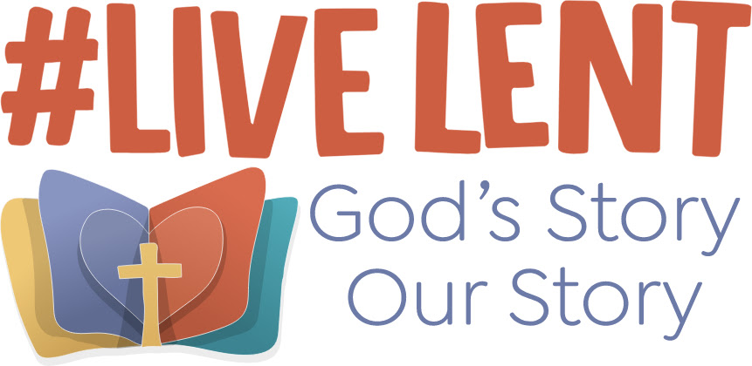

Lent Programme
Wednesday 17 February
12:30 Eucharist
Friday 19 February
12:30 Midday Prayer
13:00 to 17:30 Opportunity for personal prayer in the church
17:30 Evening Prayer
Sunday 21 February (Lent 1)
10:30 Eucharist
Wednesday 24 February
12:00 Talk: "The way to the cross in Mark’s Gospel"
12:30 Eucharist
Friday 26 February
12:30 Midday Prayer
13:00 to 17:30 Opportunity for personal prayer in the church
17:30 Evening Prayer
Sunday 28 February (Lent 2)
10:30 Eucharist
Wednesday 3 March
12:00 Talk: "The way to the cross in Matthew’s Gospel"
12:30 Eucharist
Friday 5 March
12:30 Midday Prayer
13:00 to 17:30 Opportunity for personal prayer in the church
17:30 Evening Prayer
Sunday 7 March (Lent 3)
10:30 Eucharist
Wednesday 10 March
12:00 Talk: "The way to the cross in Luke’s Gospel"
12:30 Eucharist
Friday 12 March
12:30 Midday Prayer
13:00 to 17:30 Opportunity for personal prayer in the church
17:30 Evening Prayer
Sunday 14 March (Mothering Sunday – Lent 4)
10:30 Eucharist
Wednesday 17 March (St Patrick)
12:00 Talk: "The way to the cross in John’s Gospel"
12:30 Eucharist
Friday 19 March (St Joseph)
12:30 Eucharist
13:00 to 17:30 Opportunity for personal prayer in the church
17:30 Evening Prayer
Sunday 21 March (Lent 5)
10:30 Eucharist
Wednesday 24 March (Walter Hilton, Paul Couturier, Oscar Romero)
12:00 Talk: "The Psalms of the Passion"
12:30 Eucharist
Thursday 25 March - The Annunciation
12:30 Eucharist
Friday 26 March
12:30 Midday Prayer
13:00 to 17:30 Opportunity for personal prayer in the church
17:30 Evening Prayer
Palm Sunday 28 March
10:30 Blessing of Palms and Eucharist
Monday 29 March – Monday in Holy Week
12:30 Eucharist with Talk "The journey of Dante Alighieri" (1)
Tuesday 30 March – Tuesday in Holy Week
12:30 Eucharist with Talk "The journey of Dante Alighieri" (2)
Wednesday 31 March - Wednesday in Holy Week
12:30 Eucharist with Talk: "The journey of Dante Alighieri" (3)
Thursday 1 April – Maundy Thursday
18:00 Liturgy of the Lord’s Supper
Friday 2 April – Good Friday
14:00 “The Last Hour” – Liturgy of the Passion
Easter Day 4 April
10:30 Blessing the Easter Candle and Eucharist of the Resurrection
A.W.D. 24 February 2021

